**The impact of setback regulations on PV deployment strategies in Gyeonggi province, South Korea**

Seungho Jeon

*Climate & Environment Data Center, Gyeonggi Research Institute, South Korea*

**Abstract**

This study investigates the impact of setback regulations on photovoltaic (PV) deployment in Gyeonggi Province, South Korea, a region with high renewable energy demand. Using GIS-based spatial analysis, PV-suitable sites were identified and analyzed under current and no setback scenarios. Observed PV data informed calculations for PV generation potential and economic viability. Removing setback regulations increases PV installation area by 78.42%, capacity by 38.44%, and generation potential by 37.91%. However, this expansion reduces efficiency, especially in farmland and mountainous areas. Agrophotovoltaic and eco-conscious strategies are suggested to address environmental concerns. The residential sector offers the highest potential, highlighting the value of rooftop PV policies. Three deployment strategies were evaluated: price-based, quantity-based, and full deployment. The price-based strategy is cost-efficient but falls short of targets. The full deployment strategy meets PV goals but at higher costs. The quantity-based strategy balances scalability and cost-efficiency, reducing costs by 42.7% without setback regulations. This study underscores the importance of tailored policies to enhance PV deployment in densely populated, land-constrained areas, offering insights for achieving renewable energy targets.

**Keywords:** PV potential, PV deployment strategy, Setback regulation, GIS analysis, Supply curve of PV generation

1. Introduction

As the 13th largest greenhouse gas emitter, South Korea accounted for 1.3% of global greenhouse gas emissions (Crippa et al., 2023). The country has pledged to achieve its nationally determined contribution by 2030 and carbon neutrality by 2050 (The Government of the Republic of Korea, 2021, 2020). Like many nations, South Korea views the expansion of renewable energy as a key strategy for decarbonization. Globally, renewable energy accounted 27.8% of total electricity generation, whereas in South Korea, the share was significantly lower at 6.1% (IRENA, 2023). Despite this disparity, South Korea decided to lower the 2030 renewable energy target from 30% to 22% (The Government of the Republic of Korea, 2023). The decision is based on the current government’s willingness to enlarge the role of nuclear power in the middle of energy transition.

In 2021, global renewable energy generation amounted to 7,857TWh, with hydro energy accounting for 4,400 TWh (56%), wind energy for 1,838 TWh (23%), solar energy for 1,033 TWh (13%), and other renewable sources contributing 586 TWh (8%). In 2022, South Korea generated a total of 50.4 TWh from renewable sources, with 30.7 TWh (61%) from solar energy, 11.9 TWh (24%) from bio energy, 3.4 TWh (7%) from wind energy, 3.5 TWh (7%) from hydro energy, and 0.8 TWh (1%) from other source (KEA, 2023). In South Korea, all solar energy-based power generation relies exclusively on photovoltaic (PV) technology, with no contribution from solar thermal technology. Comparing South Korea with the global renewable energy mix reveals significant differences in resource dependency. Globally, hydro energy dominates, accounting for 56% of total renewable generation, whereas South Korea relies heavily on solar energy, which constitutes 61% of its renewable energy production, far surpassing the global average of 13%. South Korea’s renewable energy strategy hinges on solar energy, emphasizing the importance of scaling up its adoption to secure a sustainable energy transition.

According to South Korea’s carbon neutrality scenario(Presidential Commission on Carbon Neutrality and Green Growth, 2021), renewable energy generation in 2050 is projected to reach 889.9 TWh under ‘Scenario A’ and 736.0 TWh under ‘Scenario B’. Assuming the current share of solar energy in renewable generation (61%) remains constant, solar power generation in 2050 would amount to 542 TWh under ‘Scenario A’ and 449 TWh under ‘Scenario B’. South Korea’s PV potential was estimated at 137,347 TWh/year, 3,117 TWh/year, and 495 TWh/year for theoretical, geographical & technical, and economic potential (KEA, 2020), respectively, based on categorization of PV potential from previous studies (Köberle et al., 2015; Sun et al., 2013; Zhang et al., 2020). The minimum required amount (449TWh) for carbon neutrality can likely be met if the economic potential (495TWh) is fully utilized. Currently, only 6% (30.7TWh) of the economic PV potential is currently being utilized.

1. Background and research framework
   1. Regulatory barriers to PV deployment

Several factors contribute to the underutilization of PV potential. The composition of the renewable energy portfolio and energy mix is shaped by a variety of influences, including the natural environment, energy security, economic consideration and politic factors (Papież et al., 2018). While energy policies can promote renewable energy expansions by internalizing its positive externalities (Abdmouleh et al., 2015; Thapar et al., 2016), certain regulations may act as barriers. These restrictions, though aimed at preventing the rapid and poorly planned expansion of renewable energy, inadvertently hinder its development. In many countries, environmental licensing is cited as a major cause of delays in renewable energy projects (deCastro et al., 2019; Hoffmann et al., 2019; Salvador et al., 2019; Snyder and Kaiser, 2009; Vasconcelos et al., 2022). In South Korea, the issue of setback regulation has sparked significant controversy. These regulations require PV facilities to maintain a minimum distance from designated areas such as residential zones, roads, parks, and cultural heritage sites to be eligible for installation. This has largely been driven by local opposition to PV installations, leading many local governments to enforce setback regulations (Ko, 2023). Local residents often resist PV facilities due to concerns about environmental degradation and visual impacts (Chiabrando et al., 2011; Sun et al., 2021; Tsoutsos et al., 2005; Wüstenhagen et al., 2007). Although efforts such as sharing economic benefits from PV projects (Fina et al., 2019; Henni et al., 2021; Perger et al., 2021; van den Berg and Tempels, 2022), involving residents in the development process (Simpson, 2018), and building trust in PV systems (Park and Ohm, 2014) have been introduced to improve acceptance, resident opposition remains a significant barrier to the expansion of PV facilities.

In South Korea, setback regulations are particularly detrimental due to two key factors: (i) the country's heavy reliance on PV, which accounts for 61% of its renewable energy generation, and (ii) its limited land availability. Furthermore, South Korea ranks 22nd globally in population density, with 530 people per km2 among 216 countries (Worldbank, 2024). These factors make it challenging to identify suitable sites that meet all the conditions for installing PV facilities, highlighting the urgent need to better understand the effects of setback regulations. Previous studies have investigated the effects of setback regulations on PV deployment potential at national or provincial scales. For example, they indicate that under nationwide setback regulations, only 23% of geographic & technical potential PV generation (566 TWh out of 2,507 TWh) can be utilized. However, relaxing these regulations to 300 meters and 100 meters could increase the utilization rate to 25% (625 TWh) and 54% (1,365 TWh), respectively (Hong et al., 2022). In Incheon province, which has the least restrictive setback regulations, 68% of the potential site area is usable. In contrast, regions such as Chungbuk and Chungnam, which face the strictest regulations, can only utilize 22% of their potential site areas (Chang and Cho, 2023). Additionally, in specific counties like Hampyeong (Jeollanam-do), Hamyang (Gyeongsangnam-do), and Gumi (Gyeongsangbuk-do), setback regulations restrict the available PV installation areas to 54%, 53%, and 32%, respectively (Kwon et al., 2020).

* 1. Study area

This study aims to assess the impact of setback regulations on PV potential in Gyeonggi Province, one of South Korea’s 17 provinces. Gyeonggi Province comprises 31 cities, of which 12 cities have implemented setback regulations (see Supplementary Materials for details). While the specific regulations differ across cities, they generally pertain to minimum setback distances from residential areas and roads, ranging from 100 to 500 meters. Gyeonggi Province accounts for 10.2% of South Korea’s total area (KOSIS, 2024a) and is home to 27% of the population (KOSIS, 2024b). It is the region where the introduction of renewable energy is most urgently needed among South Korea’s 17 provinces (Jeon and Kim, 2024). First, a regionally differentiated electricity pricing system is under discussion, where a region’s electricity self-sufficiency rate is expected to determine retail electricity prices. From 2019 to 2021, Gyeonggi’s average electricity self-sufficiency rate was 59.34% (Lee and Lee, 2023), necessitating an increase in power supply to avoid economic losses from rising electricity prices. Second, 7 headquarters and 17 facilities of global RE100 companies are located in Gyeonggi Province (Climate Group RE100, 2024; GRI, 2023). Providing these companies with locally produced renewable energy (e.g., through a power purchase agreement) will help them achieve their RE100 goals and mitigate economic losses. Third, the governor of Gyeonggi Province is committed to expanding PV (ICLEI, 2023). Despite the national renewable energy supply target being reduced in the 10th Basic Plan for Electricity Supply and Demand, the governor has set an ambitious goal of installing 9 GW of PV during his term. In this context, the expansion of PV facilities in Gyeonggi Province is crucial.

* 1. Related studies and research gaps

Numerous studies have employed GIS-based multi-criteria decision-making (MCDM) approaches to identify suitable locations for solar PV deployment. These studies commonly incorporate geographic, technical, environmental, and socio-economic criteria—such as solar irradiance, slope, proximity to infrastructure, and land use—to develop spatial suitability maps (Alami Merrouni et al., 2018; Carrión et al., 2008; Habib et al., 2020). One widely used constraint in such analyses is the distance from sensitive areas, particularly residential zones and roads. For example, Uyan (2013) excluded areas within 500 meters of residential zones, and Watson and Hudson (2015) applied similar buffer distances to reflect environmental and visual considerations. However, in most of these cases, such distance thresholds are applied uniformly across the study area based on general planning norms or expert judgment, rather than reflecting locally enforced legal regulations. Brewer et al. (2015) added a valuable perspective by incorporating social preference data into the siting of utility-scale solar farms, highlighting the importance of public acceptance. However, their analysis did not include spatially variable legal regulations such as setback ordinances. A recent study conducted a GIS-based analysis to evaluate the PV installation potential in 193 industrial complexes across Gyeonggi Province, the same region addressed in this study (Park et al., 2024). Their research found that setback regulations imposed by local governments significantly restrict the feasible installation area, resulting in a potential capacity loss of approximately 0.47 GW. These regulations posed a substantial barrier to achieving the provincial PV target of 3.8 GW.

This study advances the existing literature by introducing several novel contributions. First, it explicitly incorporates municipal-level setback regulations based on legally enacted ordinances, capturing policy heterogeneity across cities. Second, the analysis is conducted across eight distinct land-use types, allowing for a more differentiated understanding of PV deployment potential. Third, instead of relying on generalized assumptions, the PV capacity and expected generation were estimated using parameters derived from actual PV installations within the study region, enhancing the empirical relevance of the results. Finally, the study constructs a geospatial supply curve that integrates spatial constraints and cost metrics, offering a policy-relevant framework for assessing scalable PV deployment under different regulatory scenarios.

* 1. Research objectives

This study addresses the following research questions: i) How do setback regulations affect the total area, capacity, and generation potential of PV deployment in Gyeonggi Province? ii) To what extent does the removal of setback regulations influence the land-use efficiency and capacity efficiency of PV deployment across different land-use types? iii) What are the key characteristics and policy considerations of PV deployment across different land-use types in the presence and absence of setback regulations? iv) Which deployment strategy (price-based, quantity-based, or full deployment) offers the most effective balance of cost, generation, and emissions reduction under different setback regulation scenarios?

This study follows the methodology outlined in Fig. 1. First, PV-eligible individual plots in Gyeonggi Province are categorized into nine land-use types. Using GIS tools, suitable plots are identified by excluding currently installed PV sites, mountains with slopes exceeding 15 degrees, and legally protected farmland and mountainous areas. Area factors, density factors, and capacity factors are applied to estimate the annual generation potential of these plots. To evaluate economic viability, levelized cost of electricity (LCOE) data from external sources are incorporated to derive the geospatial supply curve of PV generation. Based on this analysis, three deployment strategies—quantity-based, price-based, and full deployment—are proposed and assessed for their impact on generation, greenhouse gas reductions, and costs under different setback regulation scenarios.

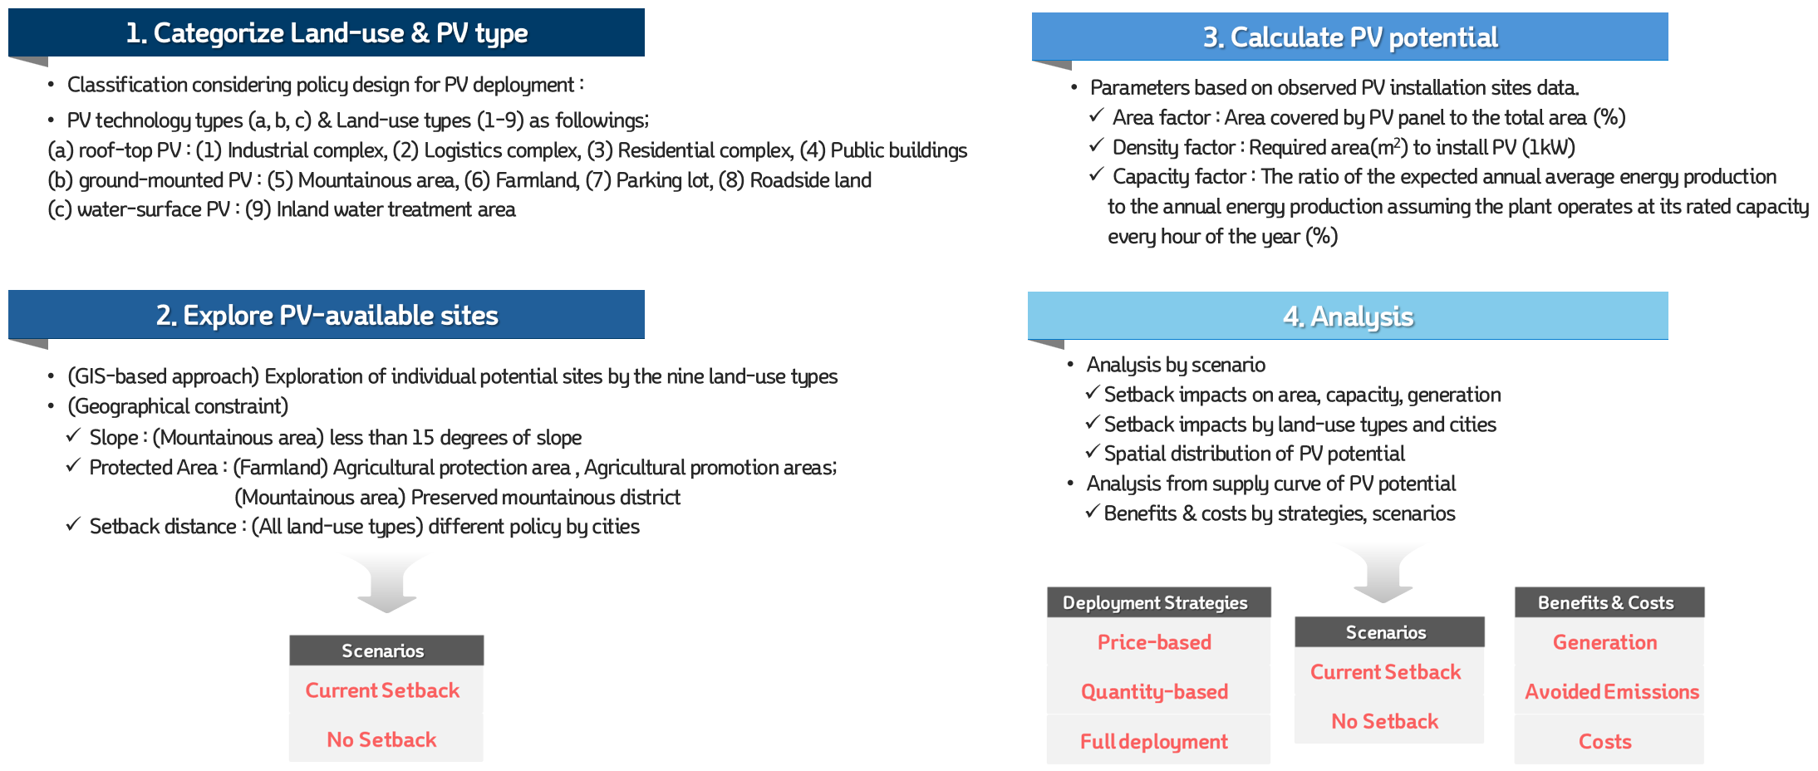

**Fig. 1.** Study flow of this study

1. Methodology
   1. Site categorization

This study utilized GIS tools to investigate PV-eligible sites in Gyoenggi province, categorized into nine land-use types. Land-use types exhibit distinct socioeconomic and physical characteristics. For example, from a legal perspective, governments establish management and planning regulations for each land-use type. From an economic perspective, cases like agrophotovoltaic (AgroPV) emphasize balancing agricultural revenue with income from PV generation, whereas in commercial areas, potential restrictions on business activities (e.g., parking space or roof-top use limitations) must be evaluated. In terms of social aspects, residents in densely populated commercial areas may show low acceptance of PV installations due to aesthetic concerns. Moreover, the physical differences among land-use types are notable. For example, mountainous areas might have higher capacity factors due to the lack of tall surrounding structures, but issues such as slope stability and soil condition require attention. Additionally, while industrial complexes and residential buildings can leverage existing infrastructure for PV installation, farmland and mountainous regions often require significant land preparation. Given these multidimensional differences, governments implement PV deployment policies tailored to specific land-use types (Alkousaa, 2024; California energy comission, 2024; Nealon, 2023). Reflecting these distinctions, this study categorizes PV-eligible sites by land-use types as follows to support the development of effective policies:

* Industrial complex: designated under the "Industrial Sites and Development Act" to promote balanced industrial development and national economic growth. (ex. national industrial complex, general industrial complex, urban high-tech industrial complex, agricultural industrial complex). The term ‘Industrial’ will be used to refer to ‘Industrial complex’ hereafter.
* Logistics complex: designed for the storage, management, collection, delivery, and adjustment of cargo supply. These facilities often include areas for loading, sorting, packaging, and labeling (ex. storage facilities, logistics terminals, inland logistics bases). The term ‘Logistics’ will be used to refer to ‘Logistics complex’ hereafter.
* Residential complex: designed to accommodate multiple households within a single structure. These complexes allow independent living spaces while sharing walls, corridors, stairs, and other communal facilities (ex. apartments, row houses, multiplex housing. studio apartments, officetels). The term ‘Residential’ will be used to refer to ‘Residential complex’ hereafter.
* Public building: constructed by the government, local governments, or affiliated institutions to enhance public convenience and provide essential services (ex. cultural centers, sports complexes, parks, and other public amenities. The term ‘Public’ will be used to refer to ‘Public building’ hereafter.
* Mountainous area: Land predominantly covered with forests, including trees and bamboo. These areas exclude farmland, grassland, residential areas, and road sites. Mountainous areas often serve ecological, recreational, or conservation purposes (ex. Forested mountains and conservation woodlands). The term ‘Mountain’ will be used to refer to ‘Mountainous area’ hereafter.
* Farmland: used for cultivating crops, including fields, paddies, orchards, and perennial plant cultivation sites, regardless of their legal classification. Grasslands established under the "Grassland Act" or other exceptions specified by presidential decree are excluded. (ex. paddy fields, dry fields)
* Parking lot: designated for automobile parking as defined by the "Parking Lot Act". Parking lots serve nearby buildings or facilities and may also be available for public use (ex. On-street parking lots, off-street parking lots, attached parking lots, public parking lots, private parking lots). The term ‘Parking’ will be used to refer to ‘Parking lot’ hereafter.
* Roadside land: unused spaces between roads and road facilities, often managed as green spaces by the Korea Expressway Corporation. (ex. interchanges, junctions, and toll stations).
* Inland water treatment area: designed to store or manage water in rivers, river zones, or coastal areas to secure agricultural and rural water supply (ex. reservoirs, lakes, dams). The term ‘Water’ will be used to refer to ‘Inland water treatment area’ hereafter.

Certain legal regulations make it impossible to install PV systems in specific areas of farmland and mountainous areas. Among mountainous areas, PV installations are prohibited in preserved mountainous districts. These preserved mountainous districts are further categorized into mountainous districts for forestry use and mountainous districts for public interest. Mountainous districts for forestry use are designated by the Korea Forest Service to enhance forestry production functions, such as forest resource creation and forestry management infrastructure development. Mountainous districts for public interest are designated to serve both forestry production and public purposes, such as disaster prevention, water resource protection, biodiversity conservation, landscape preservation, and public health and recreation enhancement. Additionally, even if an area is not designated as a preserved mountainous district, regions with an average slope exceeding 15 degrees are prohibited from PV system installation. Farmland classified as agricultural promotion areas are not permitted to host PV systems, and agricultural protection areas larger than 1 hectare are also prohibited from PV installations. This study applied these regulations on PV installation when assessing site feasibility. The setback regulations, however, are discussed separately in 3.4 Setback regulation scenario section.

* 1. Calculation of PV potential

The annual (8,760 hours) theoretical potential generation ( in kWh) of PV in a given site () with area ( in m2) can be calculated based on the global horizontal irradiation ( in kW/m2) using the following equation (1).

(1)

However, the theoretical potential has limitations in providing meaningful information for policymakers. To derive more realistic estimates of PV potential, geographic & technical constraints (e.g., protected areas, PV module efficiency) are incorporated into the calculation as shown in the following equation (2) (Bennett et al., 2023a; Martín-Chivelet, 2016a; P. Wang et al., 2022; Wang et al., 2021; Yang et al., 2019).

(2)

Here, the geographic & technical potential ( in kWh) is calculated from the theoretical potential () in equation (1), considering geographic and technical constraints. (unitless) is the packing factor, the ratio of the total PV array area to the land area PV arrays occupy. It measures how densely the PV arrays are packed within the occupied space. (unitless) is generator-to-system area ratio, which is the ratio of the land area PV arrays occupy (including PV arrays and the spaces between them) to the total suitable land area available for the PV system. It indicates how efficiently the available area is utilized for placing PV systems. (unitless) is the performance ratio, the ratio of the actual generation achievable in practice to the ideal generation under no-losses conditions. Regardless of module efficiency and shading effect, it measures PV system losses from array temperature, surface soiling, panel degradation etc. is the module efficiency. is the shading factor. As another approach, this study calculates geographic & technical potential using equation (3).

(3)

Here, (in kWh) is annual geographical & technical potential in the individual site ()’s area ( in m2), located within a city& county (), classified as land-use type () and PV technology type (). (in m2) is the area of the individual site. (unitless) is the area factor, which represents the ratio of the land area PV arrays occupy to the total suitable land area available for the PV system. It has the exact same meaning of in equation (2). (in m2/kW) is the density factor, which represents the land area required to install 1kW of PV capacity. It indicates how densely PV systems could be installed in the given area. (unitless) is the capacity factor of a PV system, defined by the ratio of the actual power generation to theoretical power generation if the PV system has generated at its maximum power output during same period (Edalati et al., 2015; Mussard and Amara, 2018). There are two different aspects in calculating generation potential between equation (2) and (3). The first one is the measurement of PV installation size: PV array area (in m2) vs. PV capacity (in kW). In some previous studies (Bennett et al., 2023b; P. Wang et al., 2022; Wang et al., 2021), the solar radiation utilized by PV array area is measured, represented as in equation. (2). In contrast, other studies (Martín-Chivelet, 2016b; Yang et al., 2019) measure the installed PV capacity, represented as in equation (3). The second difference is the measurement of PV system’s efficiency (%): disaggregation into performance ratio, module efficiency, and shading effect vs. capacity factor as integrated efficiency. In some previous studies (Martín-Chivelet, 2016b; P. Wang et al., 2022; Wang et al., 2021; Yang et al., 2019), energy losses associated with solar-to-electric power conversion and shading effects are divided into three components, represented as in equation (2). In contrast, other studies (Feldman et al., 2020; Mattsson et al., 2021) apply a definition-based parameter, the capacity factor, represented as in equation (3). The numerical values for the parameters in Equation (3) (area factor, density factor, and capacity factor) are described in the following sections, with additional details provided in Table 2 and the Supplementary Materials.

* + 1. Area factor: total area to PV system area

Fig. 2 (c) illustrates the graphical concept of the area factor (). Not all of the total area can be utilized for PV system installation due to various constraints. These may include facilities unrelated to PV operation, unsuitable terrain for PV placement, or other factors. The surrounding environment varies significantly across sites, making it impractical to evaluate each site individually. In previous studies, it has been commonly assumed that 70% of the total area is available for PV installation (Dhunny et al., 2019; Martín-Chivelet, 2016a; Saraswat et al., 2021). However, in this study, area factors are calculated using actual PV installation data or, in some cases, assumed values based on land-use types.

The area factors differ based on the land-use types. For industrial complexes, logistics complexes, residential complexes, and public buildings, actual data shows that an average of 54.5% of the total area is utilized for PV system installations. In the case of parking lots, the percentage is much lower, with only 18.9% of the area being used for PV systems. Similarly, for roadside land, 28.4% of the site area is typically utilized for PV installations. For land-use types such as mountainous areas and farmland, where specific data is unavailable, this study assumes that only 5% of the total area can be used for PV systems. This assumption aligns with findings from previous studies (Chatzipanagi et al., 2023). Meanwhile, for water-surface PV systems, the area factor varies widely in prior research, ranging from 1% to 100% % (Almeida et al., 2022; Gonzalez Sanchez et al., 2021; Jin et al., 2023; Kakoulaki et al., 2023; López et al., 2022; Woolway et al., 2024). Based on these findings, this study adopts an assumed area factor of 25% for water-surface PV installations.

* + 1. Density factor: PV system area to PV capacity

Fig. 2 (d) illustrates the graphical concept of the density factor (), which represents the land area required to install 1 kW of PV capacity. Previous studies have provided different values for density factors based on the type of PV system. For roof-top PV systems, the density factor was estimated as 11.7 m2/kW for single-family buildings, and 4.7 m2/kW for both multi-family and apartment complexes (D’Agostino et al., 2022). For ground-mounted PV systems, density factors of 9.57 m2/kW and 13.16 m2/kW were reported in previous studies (Almadhhachi et al., 2024; Vyas et al., 2022). To improve land-use efficiency, emerging PV technologies such as PV trees (Almadhhachi et al., 2024; Ibrahim and Ashor, 2024; Vyas et al., 2022) and agricultural PV (Anusuya et al., 2024; Junedi et al., 2022; Safat Dipta et al., 2022). have been proposed as alternatives to conventional PV systems. In this study, the density factor values were determined using data from actual PV installation cases. To achieve 1kW of capacity, roof-top PV systems require an average of 7.23m2, whereas ground-mounted PV systems require 11.50m2 on average. For water-surface PV systems, where case data is unavailable, a density factor of 10 m2/kW is assumed based on previous studies (Almeida et al., 2022).

* + 1. Capacity factor: PV capacity to PV generation

Fig. 2 (e) illustrates the graphical concept of the capacity factor (), which reflects the ratio of actual PV power generation to its theoretical maximum output. Since PV generation is significantly influenced by weather conditions, it is crucial to apply capacity factors that account for regional weather variations. In this study, capacity factors were applied for 31 cities using electricity market data (EPSIS, 2024). Over the past six years, the national average capacity factor for PV in South Korea was 14.2%. However, in Gyeonggi Province, the average was slightly lower at 13.6%. Among the cities within Gyeonggi Province, Hwaseong City recorded the highest average capacity factor at 14.9%, while Yangju City had the lowest at 10.8%.

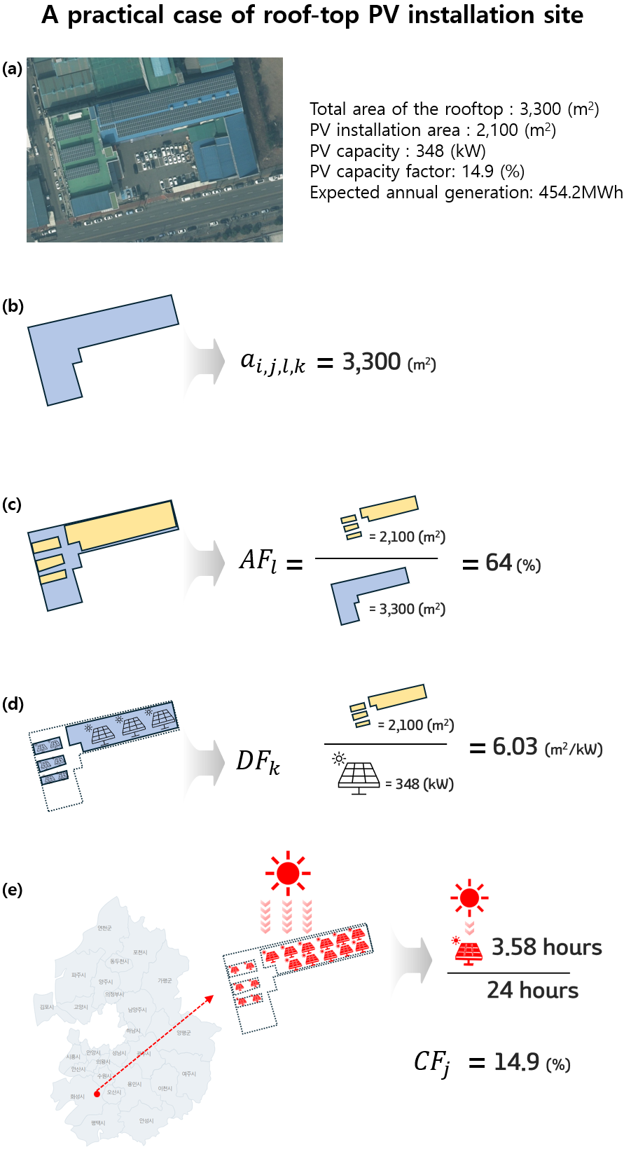

**Fig. 2.** Graphical concept of generation calculation method

* 1. Levelized costs of energy

The LCOE is a widely recognized metric for evaluating the economic performance of power generation technologies. It provides a standardized measure of the cost per generation over the lifetime of a generation system. The Korea Energy Economics Institute (KEEI) conducts comprehensive studies on LCOE, analyzing it by energy source, technology type, and region from a financial perspective (Lee and Lim, 2021). The LCOE formula is expressed as following equation (4) (see Supplementary Materials for details). The calculation of LCOE considers various costs incurred over the lifetime(*t*) of a PV system. These costs include the capital expenditure (), which represents the initial investment required for installing the PV system. Additionally, operating expenditure () accounts for the annual costs of operating and maintaining the system. Another important cost is the interest expense (), reflecting the financial costs associated with borrowing capital for the project. Similarly, the land lease expense () includes the annual costs of leasing land for PV operations. Finally, the calculation incorporates the corporate tax (), representing the taxes applied to the revenues obtained from the PV system. The denominator of the LCOE formula includes the electricity generation () of the PV system, adjusted for its degradation rate () over time. Except for the initial capital expenditure ), all other costs are annual expenditures or benefits. These are levelized over the system’s lifetime () using a financial discount rate ()[1].

(4)

The variation in solar irradiation and land prices across South Korea’s regions was incorporated into the LCOE analysis. The LCOE data are classified by 250 administrative local areas across the nation and PV types (ground-mounted and roof-top PV). For Gyeonggi Province, the region is divided into 42 local areas (reflecting 31 counties, with 6 of them further analyzed at the town level) in the LCOE data. LCOE values were calculated separately for ground-mounted and roof-top PV in each of these areas and were utilized for this study.

In 2020, the LCOE for ground-mounted PV in South Korea ranged from 123.4 Won/kWh (for 20 MW installations) to 152.0 Won/kWh (for 100 kW installations). This variation by installation size reflects economies of scale, where larger installations achieve lower costs per unit of generation. However, LCOE differences across regions were even greater, driven by geographical factors (solar irradiation), regulatory factors (restrictions on developable land), and economic factors (land prices). In Gyeonggi Province, the lowest LCOE for ground-mounted PV was recorded in Yeoncheon County at 146 Won/kWh, while the lowest LCOE for roof-top PV was 129 Won/kWh. Conversely, the highest LCOE was observed in Dongan-gu in Anyang-si, with 1,140 Won/kWh for ground-mounted PV and 1,121 Won/kWh for roof-top PV.

* 1. Setback regulation scenario

In Gyeonggi Province, 12 out of the 31 cities have implemented setback regulations (see Supplementary Materials for details). These regulations define minimum distances between PV installations and specific locations, including residential housing, roads, rivers, tourist attractions, natural parks, educational institutions, medical facilities, cultural heritage sites, historic sites, public sports facilities, and natural habitation areas. Residential housing (11 cities), roads (10 cities), and cultural heritage sites (6 cities) are the most frequently regulated by setback requirements. The setback distance from residential housing ranges between 100 meters and 500 meters depending on the city. For roads and cultural heritage sites, the setback distance is regulated between 100 meters and 300 meters. Fig. 3(a) shows the location of Gyeonggi Province within South Korea, and Fig. 3(b) illustrates the areas affected by these setback regulations within Gyeonggi Province. To analyze the impact of setback regulations, this study considers two scenarios as shown in Table 1.

**Table 1**

Scenario description

|  |  |
| --- | --- |
| Scenario | Description |
| Current Setback | PV generation potential under the existing setback regulation. This considers minimum required distances from locations such as residential area roads, cultural heritage and others |
| No Setback | PV generation potential without applying any setback regulation, allowing installations without distance constraints. |

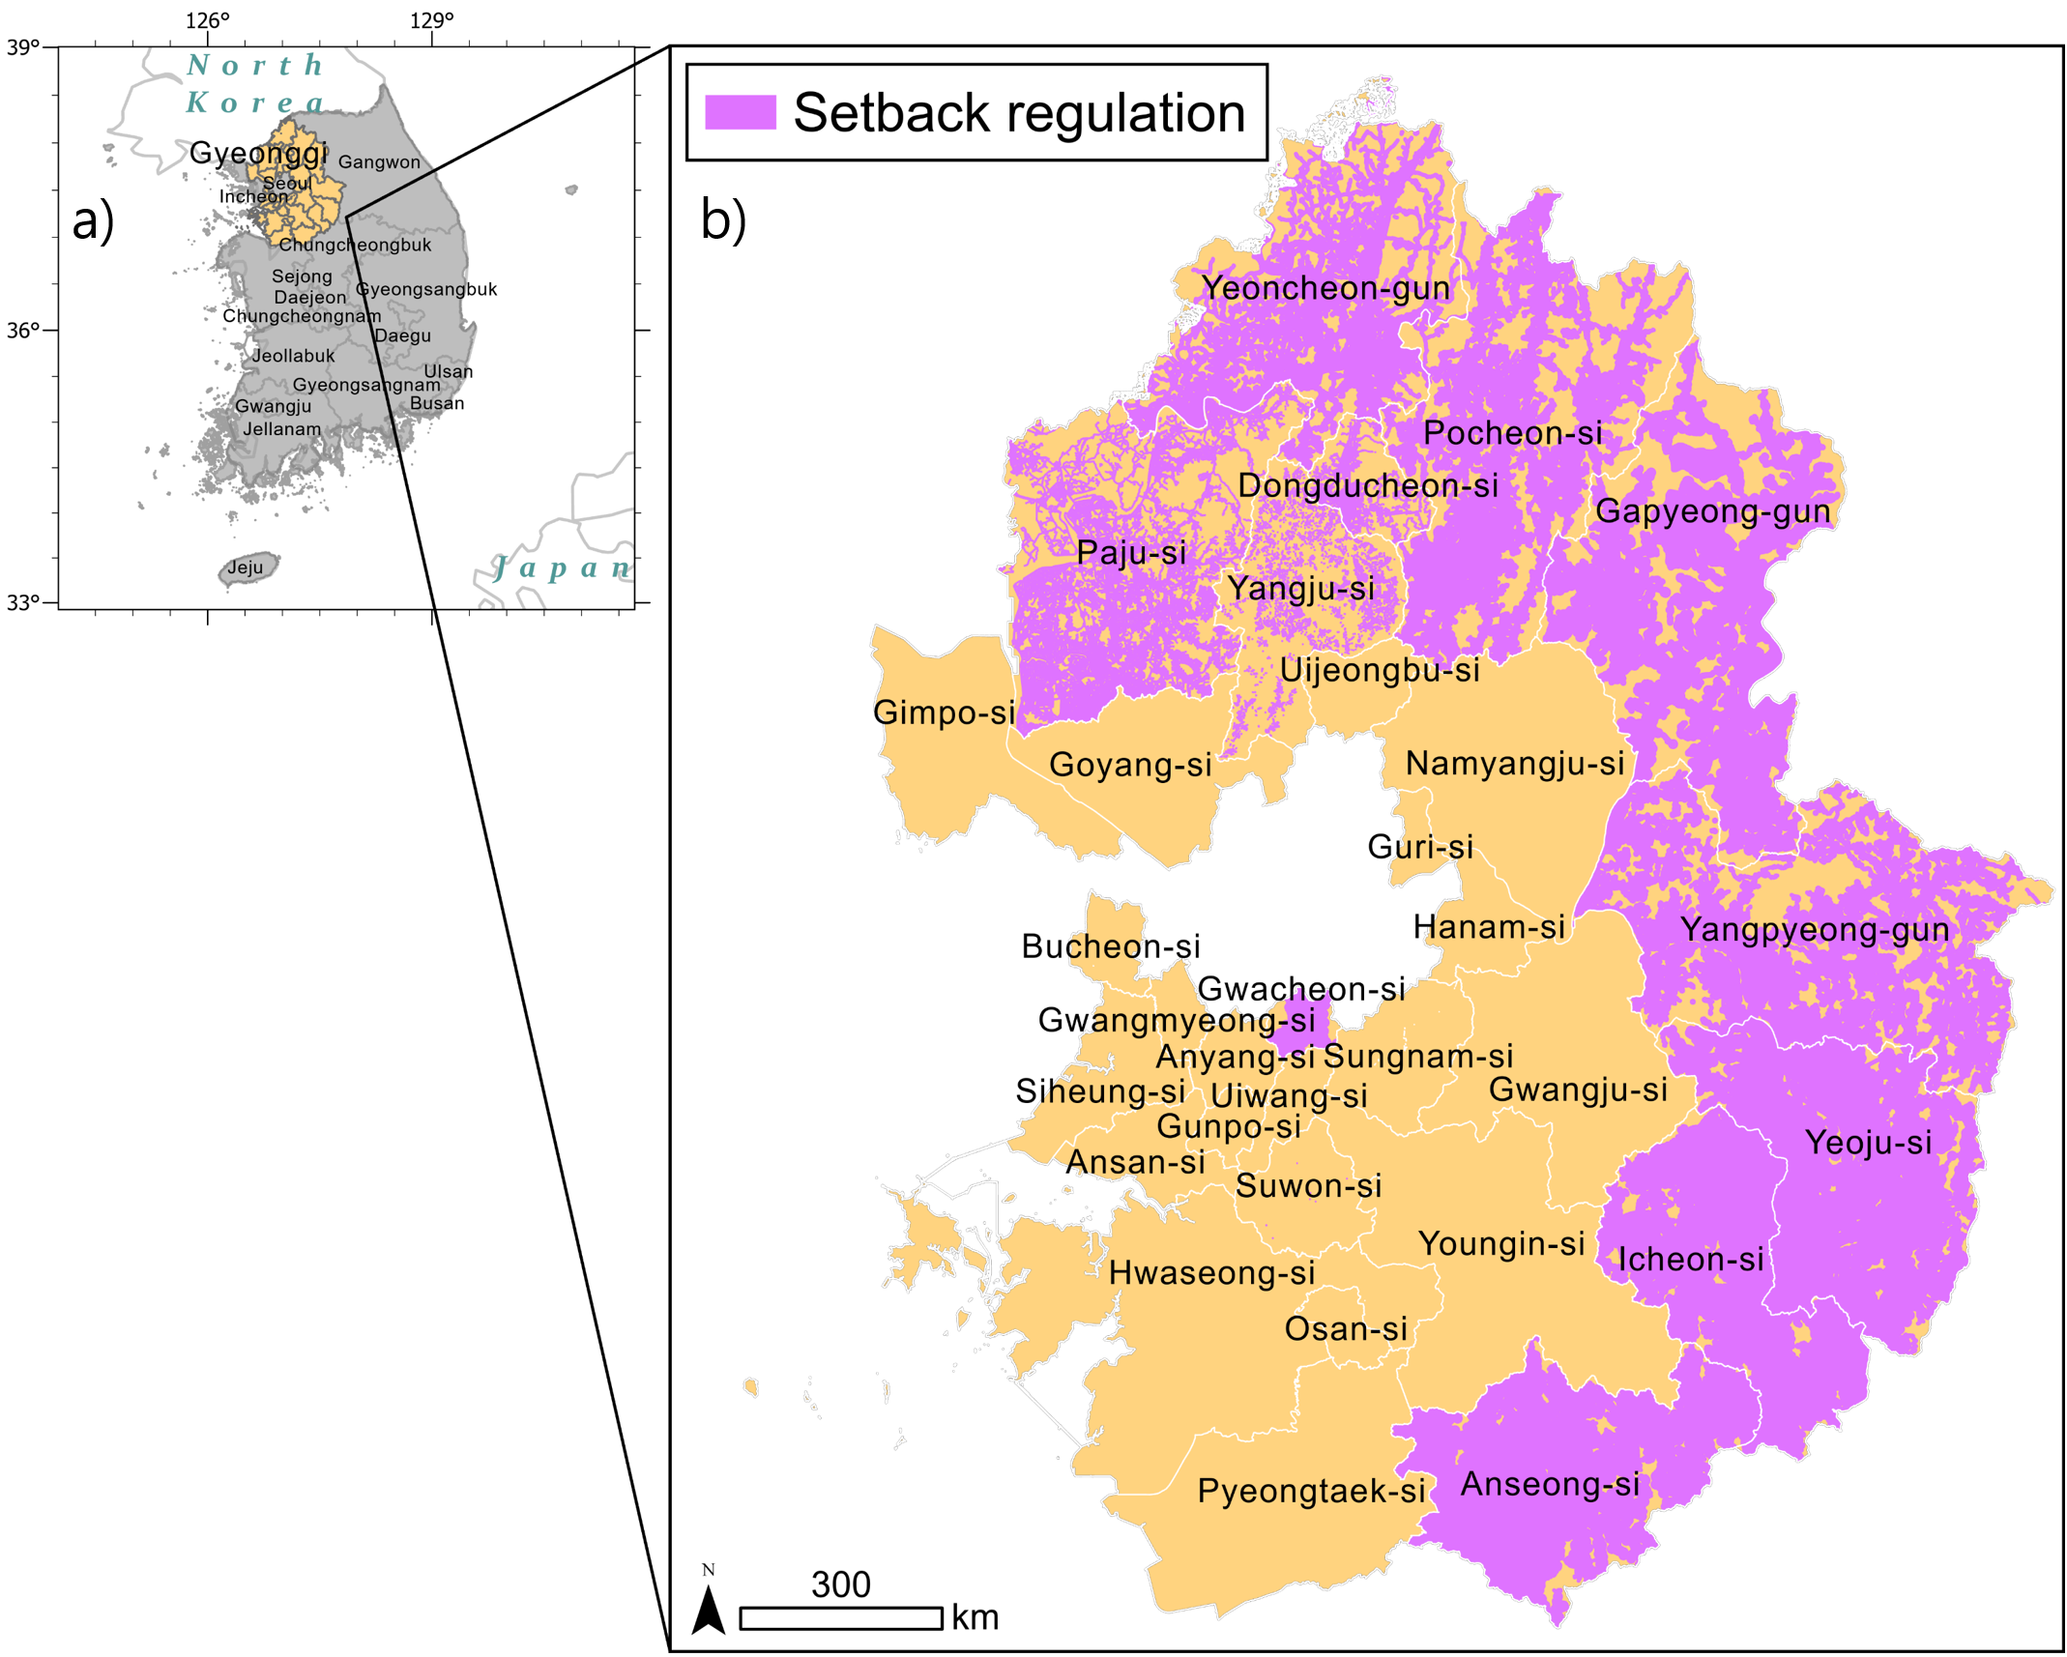

**Fig. 3.** Setback regulation area: a) Location of Gyeonggi province in South Korea, b) status of setback regulations

**Table 2**

Assumed parameters for PV potential and LCOE analysis

|  |  |  |  |  |  |
| --- | --- | --- | --- | --- | --- |
| Land-use type | PV type | Assumed parameters for calculating potential | | | LCOE |
| Area factor (%) | Density factor (m2/kW) | Capacity factor (%) |
| Industrial complex | Roof-top PV | 54.5 | 7.23 | Applied geographically  (It is applied differently depending on the city where the individual site is located.) | |
| Logistics complex |
| Residential complex |
| Public buildings |
| Mountainous area | Ground-mounted PV | 5 | 11.50 |
| Farmland | 5 |
| Parking lot | 18.9 |
| Roadside land | 28.4 |
| Water | Water-surface PV | 25 | 10 |

1. Results and discussion
   1. Geographic & technical potential of PV

Fig. 4(a) shows the PV-eligible sites under the No Setback scenario, while Fig. 4(b) provides a magnified view of selected areas, showcasing PV-eligible sites across all land-use types. Table 3 summarizes the geographic & technical potential analysis in Gyeonggi Province, focusing on available PV-installation area, capacity, and annual generation under the Current Setback and No Setback scenarios. First, the total area available for PV installation in Gyeonggi Province under the Current Setback scenario is 682.45 km2, accounting for 6.7% of the province’s total area (10,171 km2). Under the No Setback scenario, the available area increases significantly by 78.42%, reaching 1,217.60 km², or 12% of the province’s total area. Second, the PV capacity potential also shows a notable difference between the two scenarios. In the Current Setback scenario, the PV capacity is estimated at 8.97 GW. By comparison, the No Setback scenario results in a 38.44% increase, with a total capacity of 12.41 GW. When compared to the 2022 PV capacity installed in Gyeonggi Province, which was 1.8 GW, the capacities in the Current Setback and No Setback scenarios represent 4.98 times and 6.89 times the existing capacity, respectively (KEA, 2023). Furthermore, in terms of meeting Gyeonggi Province’s PV deployment target of 9 GW, the Current Setback scenario falls short by 0.03 GW, whereas the No Setback scenario exceeds the target. Third, annual generation potential varies significantly between the two scenarios. In the Current Setback scenario, the annual PV generation potential is 10.87 TWh, which increases by 37.91% to 15.00 TWh under the No Setback scenario. These figures represent 7.8% and 10.7% of Gyeonggi Province’s total electricity consumption in 2022 (140.6 TWh), respectively (KEEI, 2023). Under South Korea’s carbon neutrality scenario, Gyeonggi province’s contribution to the required PV generation (449TWh) is estimated at 2.4% and 3.3% under the Current Setback and No Setback scenarios, respectively.

To further understand these results, the analysis explores two key efficiency perspectives: i) land efficiency and ii) capacity efficiency. First, from the perspective of land efficiency, which examines how densely PV systems can be installed relative to the available area, the Current Setback scenario achieves a value of 76.08 km² per GW. Under the No Setback scenario, this value increases to 98.11 km² per GW, reflecting a 28.96% reduction in efficiency. This decline in efficiency occurs because the No Setback scenario includes more land-use types, such as farmland and mountainous areas, which have lower area factors and higher density factors compared to other land-use types. In Table 3, the available area for farmland increases by 96.52%, and for mountainous areas by 87.06%, under the No Setback scenario. These increases are far greater than the 15.41% increase for residential areas. Additionally, a comparison of roof-top PV and ground-mounted PV systems under the Current Setback scenario highlights significant differences in land and generation efficiency. The total area for roof-top PV systems, which include residential, industrial, logistics, and public building installations, is 67.99 km². In contrast, the area for ground-mounted PV systems, such as farmland, mountainous areas, roadside land, and parking lots, is significantly larger at 565.46 km². Despite the smaller area, roof-top PV systems generate 6.18 TWh annually, nearly 1.92 times the 3.21 TWh generated by ground-mounted PV systems. This difference arises because roof-top PV systems can be installed with higher area factors and lower density factors, enabling more efficient land use. Second, from the perspective of capacity efficiency (i.e. capacity factor), the Current Setback scenario achieves 1.212 TWh per GW. This figure decreases slightly to 1.209 TWh per GW in the No Setback scenario, representing a 0.25% reduction. While this decrease is not substantial, it indicates that the No Setback scenario includes regions with lower capacity factors, which contribute less efficiently to electricity generation.

Overall, while the No Setback scenario increases the total area and capacity available for PV installation, it results in reduced efficiency in land and capacity utilization. These findings highlight the importance of balancing quantitative expansion with qualitative efficiency in PV deployment strategies.

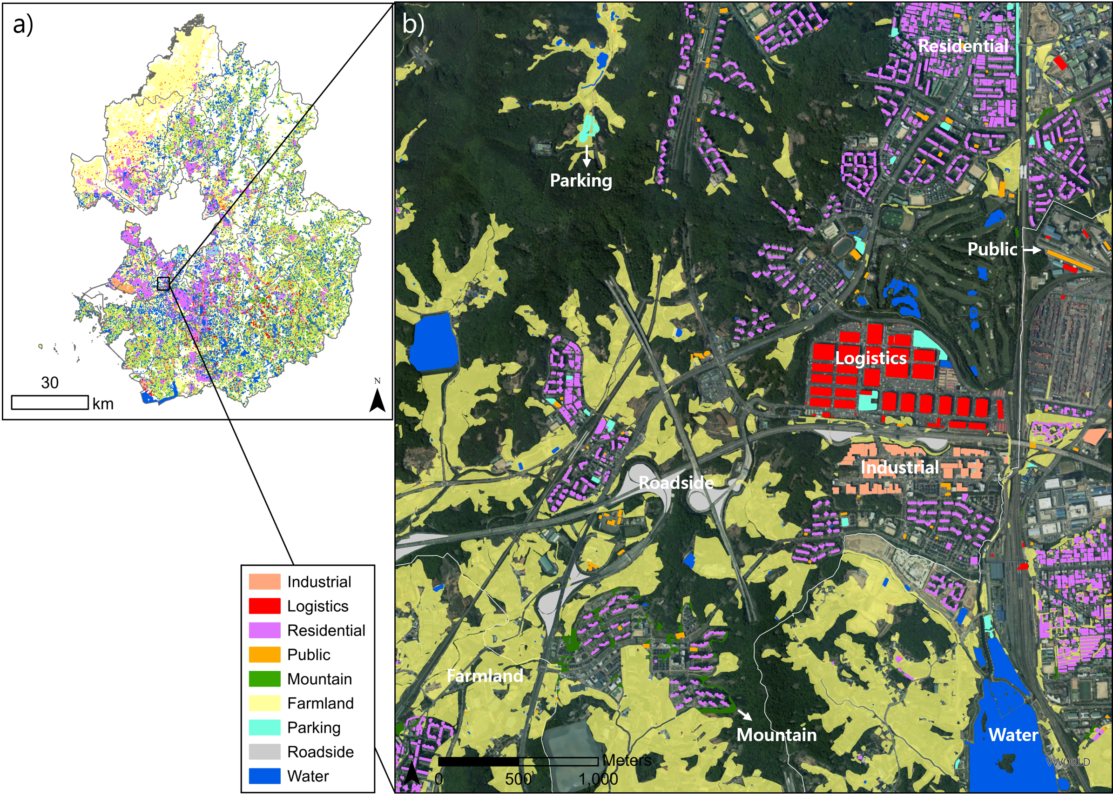

**Fig. 4.** Spatial distribution of PV-eligible installation sites under No Setback scenario: a) Overall distribution and b) magnified view of selected areas

**Table 3**

Impact of setback scenarios on area, capacity and generation by land-use type

|  |  |  |  |  |  |  |  |  |  |
| --- | --- | --- | --- | --- | --- | --- | --- | --- | --- |
| Land-use type | Area (km2, %) | | | Capacity (GW, %) | | | Generation (TWh, %) | | |
| Current Setback | No Setback | Inc* (%) | Current Setback | No Setback | Inc (%) | Current Setback | No Setback | Inc (%) |
| Total | 682.45 (100%)** | 1217.60  (100%) | 78.42 | 8.97  (100%) | 12.41  (100%) | 38.44 | 10.87  (100%) | 15.00  (100%) | 37.91 |
| Residential | 38.70  (5.67%) | 44.66  (3.67%) | 15.41 | 2.92  (32.54%) | 3.37  (27.12%) | 15.41 | 3.49  (32.14%) | 4.02  (26.83%) | 15.13 |
| Industrial | 21.76  (3.19%) | 25.29  (2.08%) | 16.24 | 1.64  (18.30%) | 1.91  (15.36%) | 16.24 | 2.00  (18.41%) | 2.33  (15.56%) | 16.52 |
| Logistics | 3.15  (0.46%) | 5.45  (0.45%) | 72.87 | 0.24  (2.65%) | 0.41  (3.31%) | 72.87 | 0.29  (2.62%) | 0.49  (3.28%) | 72.70 |
| Public | 4.38  (0.64%) | 5.62  (0.46%) | 28.33 | 0.33  (3.68%) | 0.42  (3.41%) | 28.33 | 0.40  (3.64%) | 0.51  (3.39%) | 28.20 |
| Farmland | 290.60  (42.58%) | 571.08  (46.90%) | 96.52 | 1.26  (14.09%) | 2.48  (20.01%) | 96.52 | 1.54  (14.17%) | 2.99  (19.91%) | 93.67 |
| Mountain | 266.59  (39.06%) | 498.68  (40.96%) | 87.06 | 1.16  (12.93%) | 2.17  (17.47%) | 87.06 | 1.44  (13.20%) | 2.65  (17.69%) | 84.81 |
| Roadside | 6.87  (1.01%) | 8.74  (0.72%) | 27.33 | 0.17  (1.89%) | 0.22  (1.74%) | 27.33 | 0.20  (1.88%) | 0.26  (1.74%) | 27.07 |
| Parking | 1.40  (0.21%) | 1.70  (0.14%) | 21.39 | 0.02  (0.26%) | 0.03  (0.23%) | 21.39 | 0.028  (0.25%) | 0.034  (0.22%) | 21.45 |
| Water | 49.00  (7.18%) | 56.37  (4.63%) | 15.04 | 1.23  (13.67%) | 1.41  (11.35%) | 15.04 | 1.49  (13.67%) | 1.71  (11.38%) | 14.86 |
| * Inc (%) refers to the percentage increase from the Current Setback scenario to the No Setback scenario.  ** The numbers (%) in parentheses indicate the proportion of the total value. | | | | | | | | | |

Fig. 5 shows the potential increase in PV generation for land-use types when setback regulations are removed. Detailed numerical values are available in Table 3. In Gyeonggi Province, residential areas account for the highest potential generation in both scenarios due to the region's high population density. Although Gyeonggi Province represents only 10.2% of South Korea’s total land area, it accommodates 27.4% of the nation’s population. This concentration of people results in a large number of residential buildings, which translates to significant PV potential. Under the Current Setback scenario, residential areas have a PV generation potential of 3.49 TWh, which increases by 15.19% to 4.02 TWh in the No Setback scenario. These values correspond to 16.52% and 19.03% of Gyeonggi Province’s total residential electricity consumption in 2021, which was 21.13 TWh. This finding indicates that policies aimed at supporting roof-top PV installations on residential buildings could be instrumental in accelerating deployment during the early stages of a PV rollout. Notably, the government has announced plans to introduce Renewable Energy Certificates (RECs) for self-consumption PV starting next year, which could significantly boost new PV installations in the residential sector.

In industrial, the potential generation under the Current Setback scenario is 2.00 TWh, increasing by 16.52% to 2.33 TWh in the No Setback scenario. Logistics show an even more significant increase, with potential generation rising from 0.29 TWh to 0.49 TWh, a 72.70% increase. Together, the industrial and logistics sectors account for 3.09% of Gyeonggi Province’s total industrial electricity consumption in 2022 (KEEI, 2023) under the Current Setback scenario and 3.81% under the No Setback scenario, which is equivalent to 74.07 TWh. Industrial and logistics are critical for achieving corporate RE100 targets, particularly as companies often prefer off-grid PPAs for self-consumption. This makes roof-top PV installations in these areas highly advantageous.

Farmland and mountainous areas exhibit the largest increases in potential generation when setback regulations are removed. In farmland, potential generation rises from 1.54 TWh under the Current Setback scenario to 2.99 TWh under the No Setback scenario, an increase of 93.67%. Similarly, mountainous areas see potential generation increase from 1.44 TWh to 2.65 TWh, representing an 84.81% increase. However, deploying PV systems in these areas requires addressing concerns about horticultural impacts and ecosystem preservation. For farmland, promoting AgroPV systems, which allow both crop cultivation and PV generation, is essential to maximize benefits. Similarly, for mountainous areas, it is critical to balance greenhouse gas reductions with the need for ecosystem preservation to avoid green-on-green conflicts (H. Wang et al., 2022) . While PV has clear benefits for reducing greenhouse gas emissions, its installation can negatively affect the environment by reducing carbon absorption and disturbing natural habitats (Klingler et al., 2024; Neri et al., 2019).

The potential generation on water surfaces also increases when setback regulations are removed, but the increase is comparatively modest. Under the Current Setback scenario, the potential generation from water surfaces is 1.49 TWh, which rises by 14.86% to 1.71 TWh under the No Setback scenario. This smaller increase reflects the limited impact of setback regulations on reservoirs, lakes, and dams, which are typically less affected by urban setback requirements. However, as with farmland and mountainous areas, deploying PV systems on water surfaces requires addressing environmental concerns. Water-surface PV systems[2], can lower water temperatures, reduce dissolved oxygen levels, and negatively impact plankton diversity and bird populations (Yang et al., 2024). Public buildings, owned and operated by the government, represent a land-use type where PV deployment can be actively pursued through government initiatives.

In the Current Setback scenario, the potential generation from public buildings is 0.40 TWh, increasing by 28.20% to 0.51 TWh in the No Setback scenario. These values correspond to 4.00% and 5.10% of the electricity consumption in Gyeonggi Province’s public sector in 2022, which was 10.01 TWh. Given their high acceptance for PV deployment, public buildings offer a promising starting point for government-led PV initiatives.

Roadside land also represents a promising opportunity for PV deployment. This land type is often unused and publicly owned, making it well-suited for PV installations. Under the Current Setback scenario, roadside land has a potential generation of 0.20 TWh, increasing by 27.07% to 0.26 TWh in the No Setback scenario. Similar to public buildings, roadside land benefits from high acceptance for PV deployment. Among all land-use types, parking lots have the lowest potential generation.

In the Current Setback scenario, parking lots generate 0.028 TWh, which increases by 21.45% to 0.034 TWh in the No Setback scenario. Despite the lower generation potential, parking lots offer a unique advantage as a dual-use land type, where PV systems can be installed without disrupting the land’s primary purpose. This characteristic is shared with farmland, where PV systems can coexist with agricultural activities.

In conclusion, the removal of setback regulations significantly increases the potential for PV generation across most land-use types, particularly in farmland and mountainous areas. However, this expansion requires careful consideration of land-use-specific challenges, such as environmental impacts, dual land use, and system efficiency.

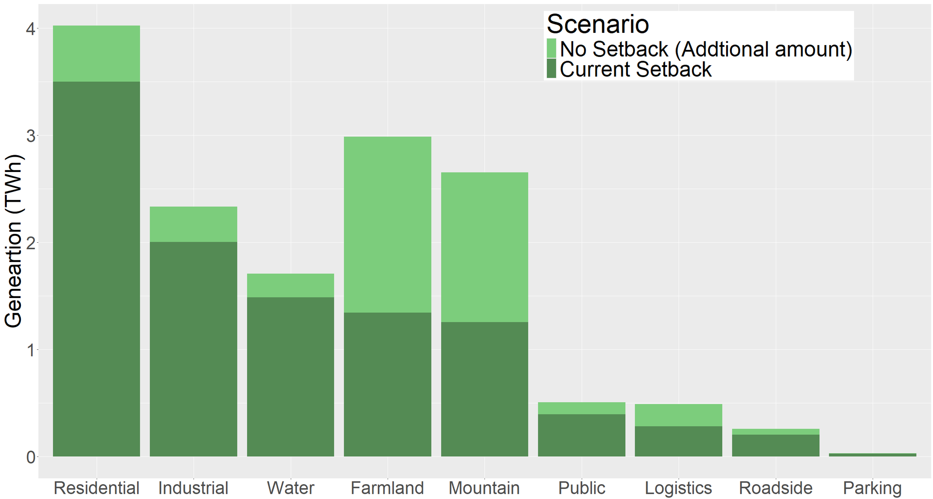

**Fig. 5.** Impact of setback regulation on potential by land-use type.

* 1. Geospatial supply curve and deployment strategies

The geospatial supply curve for PV generation is derived by applying region- and type-specific LCOE values to individual PV-eligible plots. Fig. 6 illustrates the supply curves under both the Current Setback and No Setback scenarios. In the Current Setback scenario, the curve is represented by connecting the upper segments of the bar charts between points *f* and *m*. In the No Setback scenario, the curve is formed by connecting the segments between points *f* and *n*. Using these supply curves, three deployment strategies are proposed: price-based, quantity-based, and full deployment in Table 4.

The first strategy, the price-based strategy, prioritizes the deployment of PV systems on sites with LCOE values lower than the System Marginal Price (SMP). These sites are represented by the bars below the horizontal line *g* in Fig. 6, which corresponds to the SMP for 2023. The generation under the price-based strategy represents economic potential. The second strategy, the quantity-based strategy, focuses on achieving Gyeonggi Province’s PV deployment target of 9 GW. This involves the bars to the left of the *cl* line, representing the expected generation corresponding to the capacity target[3]. The third strategy, the full deployment strategy, entails deploying PV systems on all identified eligible sites. In the Current Setback scenario, this includes the bars to the left of the *dm* line, while in the No Setback scenario, it extends to the bars to the left of the *en* line. The three strategies are evaluated across four key dimensions: generation, avoided emissions, total generation cost, and average cost of generation as summarized in Table 4 and Fig. 6.

In terms of generation, the price-based strategy produces the smallest generation potential among the three strategies. Under the Current Setback scenario, it yields 1.55 TWh of generation, as indicated by line *oa*, but increases by 161% to 4.04 TWh (line *ob*) in the No Setback scenario. However, neither scenario achieves the 9 GW target represented by line *oc*. In contrast, the quantity-based strategy achieves a fixed generation level of 10.72 TWh (line *oc*) in both scenarios since the strategy is designed to meet the quantity target. The full deployment strategy results in a generation potential of 10.87 TWh under the Current Setback scenario (line *od*), which increases by 37.91% to 15.00 TWh (line *oe*) in the No Setback scenario. Comparing the strategies, the full deployment strategy shows a larger absolute increase in generation (4.13 TWh) when setback regulations are removed compared to the price-based strategy (2.49 TWh). However, the relative increase is higher for the price-based strategy, at 160.65% versus 37.91% for the full deployment strategy.

The share of economically viable potential is defined as the portion of total PV generation potential that can be developed at a cost lower than the System Marginal Price (SMP). In the Current Setback scenario, only 1.55 TWh out of 10.87 TWh (14.26%) meets this economic criterion. When setback regulations are removed, the total generation potential increases to 15.00 TWh, and the economically viable portion rises to 4.04 TWh (26.93%). While both the total potential and the economically viable generation increase, the economically viable portion grows at a much faster rate—more than doubling compared to the modest overall increase. This suggests that removing setback regulations not only increases the quantity of deployable PV capacity, but also improves its economic quality by enabling access to more cost-effective sites.

Avoided emissions increase in line with PV generation under each strategy[4]. In the price-based strategy, avoided emissions grow from 0.69 MtCO2 to 1.79 MtCO2 when setback regulations are removed. The quantity-based strategy maintains the same level of avoided emissions (4.76 MtCO2), reflecting its fixed generation target. In the full deployment strategy, avoided emissions increase from 4.82 MtCO2 to 6.65 MtCO2, equivalent to 7.58% of Gyeonggi Province’s total emissions in 2021.

Generation costs reflect the total annual expenditure for PV electricity production, incorporating spatial variation in site-specific cost conditions across different strategies[5]. Under the quantity-based strategy, which maintains a fixed generation level of 10.72 TWh, total generation costs drop from 2,808.7 million USD in the Current Setback scenario to 1,609.4 million USD in the No Setback scenario, a 42.7% reduction. This dramatic decrease reflects the improved cost-efficiency achieved by accessing more economically favorable sites when setback regulations are removed. To better compare cost-effectiveness across strategies, average generation costs (USD/MWh) are also evaluated. The price-based strategy, which prioritizes the cheapest sites, achieves the lowest average cost at 121.7 USD/MWh in the No Setback scenario, down slightly from 124.3 USD/MWh in the Current Setback scenario. The quantity-based strategy sees a much sharper decline from 261.9 to 150.1 USD/MWh. The full deployment strategy, which includes even high cost sites, shows a more modest reduction in average generation costs, from 270.4 to 230.7 USD/MWh.

Overall, the removal of setback regulations results in significant increases in generation potential and avoided emissions across all strategies. However, the relative impacts on cost and efficiency differ across strategies: the quantity-based strategy yields the greatest cost reduction, while the price-based strategy exhibits the largest relative increase in generation potential.

**Table 4**

Comparative evaluation of PV deployment strategies: costs, emissions, and generation under setback scenarios

|  |  |  |  |  |  |  |  |
| --- | --- | --- | --- | --- | --- | --- | --- |
| Deployment strategy | | Scenario | Generation  (TWh) | Avoided emissions  (MtCO2) | Generation costs  (Million USD) | Average costs of  generation  (USD/MWh) | Average costs of  avoided emissions  (USD/tCO2) |
| (A) | (B) | (C) | (C/A) | (C/B) |
| Strategic  deployment | Price-based  strategy | Current  Setback | 1.55  (oa) | 0.69 | 192.6  (oahf) | 124.3 | 280.3 |
| No  Setback | 4.04  (ob) | 1.79 | 491.2  (obif) | 121.7 | 274.4 |
| Quantity-based strategy | Current  Setback | 10.72  (oc) | 4.75 | 2,808.7  (oclf) | 261.9 | 590.8 |
| No  Setback | 10.72  (od) | 4.75 | 1,609.4  (ockf) | 150.1 | 338.5 |
| Full  deployment | | Current  Setback | 10.87  (oe) | 4.82 | 2,940.2  (odmf) | 270.4 | 609.8 |
| No  Setback | 15.00  (oe) | 6.65 | 3,459.5  (oenf) | 230.7 | 520.3 |

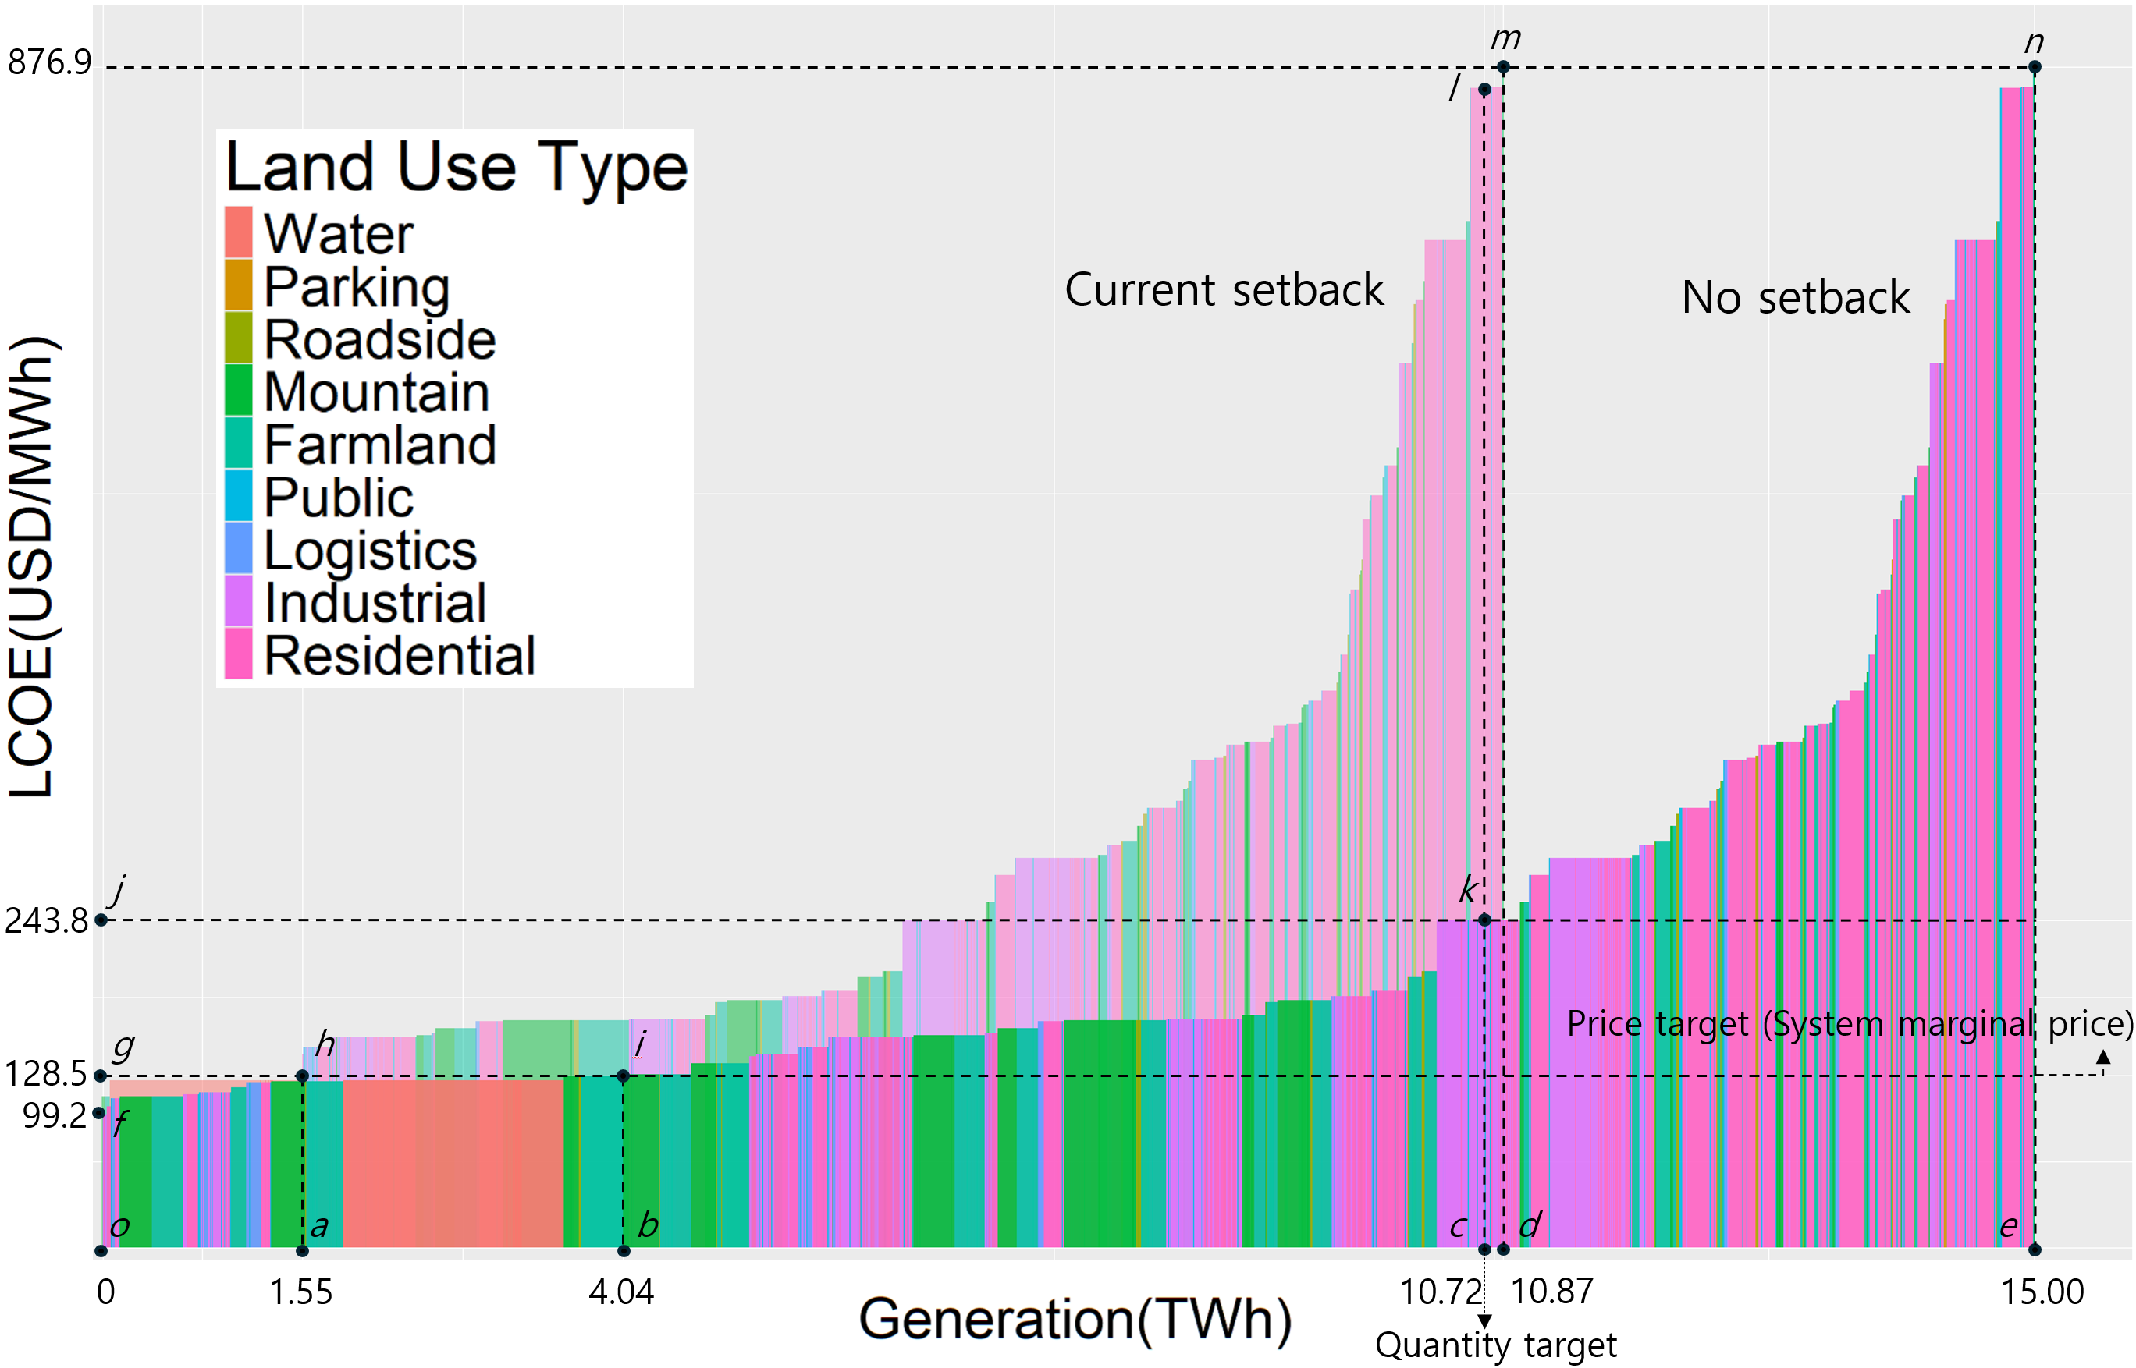

Fig. . Geospatial supply curve of PV generation: Current vs. No Setback scenarios.

1. Conclusions and policy implications
   1. Policy recommendations

This study demonstrates that municipal setback regulations significantly constrain solar PV deployment in Gyeonggi Province. Removing these regulations leads to considerable increases in deployable area, capacity, and generation potential. Notably, the removal also improves economic feasibility by unlocking access to lower-cost sites, thereby reducing average generation costs. However, this expansion introduces trade-offs in land-use and system efficiency, primarily due to the inclusion of lower-efficiency land types. These results underscore the importance of policy frameworks that balance technical potential with deployment efficiency and environmental sustainability.

To this end, the three deployment strategies evaluated—price-based, quantity-based, and full deployment—offer distinct trade-offs. In the early stages of PV expansion, a price-based strategy enables rapid and cost-efficient growth but falls short of meeting provincial targets. A quantity-based strategy strikes a better balance between scalability and cost-effectiveness, especially when setback regulations are eased. For long-term goals such as carbon neutrality, full deployment becomes essential—particularly if supported by government incentives that enhance the feasibility of high-cost sites.

Moreover, as PV deployment scales up, especially under full deployment scenarios, grid integration challenges become more pronounced. Policymakers must anticipate and support this growth by aligning PV expansion with grid infrastructure planning, investing in distributed energy resource (DER) management, and incentivizing behind-the-meter storage. Otherwise, the benefits of cost-effective PV expansion may be undermined by system-level integration costs.

Recognizing the spatial heterogeneity in land-use efficiency and LCOE, uniform policy instruments are likely to be suboptimal. Instead, differentiated incentives—such as targeted subsidies or tiered feed-in tariffs for low-efficiency areas—should be considered. Aligning these incentives with environmental and ecosystem service assessments can further ensure sustainable land use.

Finally, government-owned land, such as public buildings and roadside areas, offers administratively feasible and socially acceptable options for PV deployment. These sites can also serve as demonstration cases for community-based energy models, contributing to a just energy transition by enhancing public participation and acceptance.

* 1. Limitations

Despite offering a comprehensive spatial and economic assessment, this study has several limitations. First, it compares only two regulatory scenarios. While this contrast reveals the broad impact of the regulation, it does not capture more nuanced policy designs such as partial relaxation or location-specific adjustments. Future studies could explore intermediate setback distances or adaptive regulatory frameworks to reflect more realistic pathways. Second, this study did not conduct sensitivity analyses on key assumptions such as the area factor, density factor, and capacity factor, which vary by land use and directly affect potential estimates. Incorporating uncertainty analysis in future work would help validate the robustness of the results. Third, the LCOE data used in this study do not include certain cost components. Integration costs—such as those related to intermittency, grid upgrades, and ancillary services—were excluded. These costs can be substantial at higher penetration levels and should be accounted for in future system-level evaluations.

**Declaration of Competing Interest**

The author declares that they have no know competing financial interests or personal relationships that could have appeared to influence the work reported in this paper.

**Acknowledgement**

This work was supported by the 'Gyeonggi RE100 Platform Establishment' project through the Gyeonggi Research Institute, funded by Gyeonggi-do.

References

Abdmouleh, Z., Alammari, R.A.M., Gastli, A., 2015. Review of policies encouraging renewable energy integration & best practices. Renewable and Sustainable Energy Reviews. https://doi.org/10.1016/j.rser.2015.01.035

Alami Merrouni, A., Elwali Elalaoui, F., Mezrhab, Ahmed, Mezrhab, Abdelhamid, Ghennioui, A., 2018. Large scale PV sites selection by combining GIS and Analytical Hierarchy Process. Case study: Eastern Morocco. Renew Energy 119, 863–873. https://doi.org/10.1016/j.renene.2017.10.044

Aldersey-Williams, J., Rubert, T., 2019. Levelised cost of energy – A theoretical justification and critical assessment. Energy Policy 124, 169–179. https://doi.org/10.1016/j.enpol.2018.10.004

Alkousaa, R., 2024. German industry turns to solar in race to cut energy costs [WWW Document]. Reuters.

Almadhhachi, M., Seres, I., Farkas, I., 2024. Sunflower solar tree vs. flat PV module: A comprehensive analysis of performance, efficiency, and land savings in urban solar integration. Results in Engineering 21. https://doi.org/10.1016/j.rineng.2023.101742

Almeida, R.M., Schmitt, R., Grodsky, S.M., Flecker, A.S., Gomes, C.P., Zhao, L., Liu, H., Barros, N., Kelman, R., McIntyre, P.B., 2022. Floating solar power could help fight climate change — let’s get it right. Nature 606, 246–249. https://doi.org/10.1038/d41586-022-01525-1

Anusuya, K., Vijayakumar, K., Leenus Jesu Martin, M., Manikandan, S., 2024. Agrophotovoltaics: enhancing solar land use efficiency for energy food water nexus. Renewable Energy Focus 50. https://doi.org/10.1016/j.ref.2024.100600

Bennett, C., Blanchet, J., Trowell, K., Bergthorson, J., 2023a. Decarbonizing Canada’s energy supply and exports with solar PV and e-fuels. Renew Energy 217. https://doi.org/10.1016/j.renene.2023.119178

Bennett, C., Blanchet, J., Trowell, K., Bergthorson, J., 2023b. Decarbonizing Canada’s energy supply and exports with solar PV and e-fuels. Renew Energy 217. https://doi.org/10.1016/j.renene.2023.119178

Brewer, J., Ames, D.P., Solan, D., Lee, R., Carlisle, J., 2015. Using GIS analytics and social preference data to evaluate utility-scale solar power site suitability. Renew Energy 81, 825–836. https://doi.org/10.1016/j.renene.2015.04.017

California energy comission, 2024. Building Energy Efficiency Standards [WWW Document]. California energy comission.

Carrión, J.A., Espín Estrella, A., Aznar Dols, F., Ridao, A.R., 2008. The electricity production capacity of photovoltaic power plants and the selection of solar energy sites in Andalusia (Spain). Renew Energy. https://doi.org/10.1016/j.renene.2007.05.041

Chang, Y., Cho, I., 2023. Assessment of setback regulation policies on solar photovoltaic deployment.

Chatzipanagi, A., Taylor, N., Jaeger-Waldau, 2023. Overview of the Potential and Challenges for Agri-Photovoltaics in the European Union. Luxembourg. https://doi.org/10.2760/208702

Chiabrando, R., Fabrizio, E., Garnero, G., 2011. On the applicability of the visual impact assessment OAISPP tool to photovoltaic plants. Renewable and Sustainable Energy Reviews. https://doi.org/10.1016/j.rser.2010.09.030

Climate Group RE100, 2024. RE100 members [WWW Document]. Climate Group RE100.

Crippa, M., Guizzardi, M., Pagani, F., Banja, M., Muntean, M., Schaaf, E., Becker, W., Monforti-Ferrario, F., Quadrelli, R., Risquez Martin, A., Taghavi-Moharamli, P., Koykka, J., Grassi, G., Rossi, S., Brandao De Melo, J., Oom, D., Branco, A., San-Miguel, J., Vignati, E., 2023. GHG emissions of all world countries. European Union. https://doi.org/10.2760/235266

D’Agostino, D., Parker, D., Melià, P., Dotelli, G., 2022. Optimizing photovoltaic electric generation and roof insulation in existing residential buildings. Energy Build 255. https://doi.org/10.1016/j.enbuild.2021.111652

deCastro, M., Salvador, S., Gómez-Gesteira, M., Costoya, X., Carvalho, D., Sanz-Larruga, F.J., Gimeno, L., 2019. Europe, China and the United States: Three different approaches to the development of offshore wind energy. Renewable and Sustainable Energy Reviews. https://doi.org/10.1016/j.rser.2019.04.025

Dhunny, A.Z., Doorga, J.R.S., Allam, Z., Lollchund, M.R., Boojhawon, R., 2019. Identification of optimal wind, solar and hybrid wind-solar farming sites using fuzzy logic modelling. Energy 188. https://doi.org/10.1016/j.energy.2019.116056

Edalati, S., Ameri, M., Iranmanesh, M., 2015. Comparative performance investigation of mono- and poly-crystalline silicon photovoltaic modules for use in grid-connected photovoltaic systems in dry climates. Appl Energy 160, 255–265. https://doi.org/10.1016/j.apenergy.2015.09.064

EPSIS, 2024. Regional capacity factor of photovoltaics [WWW Document]. Electric Power Statistics Information System. URL https://epsis.kpx.or.kr/epsisnew/selectKnreUtilRtoChart.do?menuId=010100 (accessed 11.25.24).

Feldman, D., Ramasamy, V., Fu, R., Ramdas, A., Desai, J., Margolis, R., 2020. U.S. Solar Photovoltaic System and Energy Storage Cost Benchmark: Q1 2020.

Fina, B., Auer, H., Friedl, W., 2019. Profitability of PV sharing in energy communities: Use cases for different settlement patterns. Energy 189. https://doi.org/10.1016/j.energy.2019.116148

GIR, 2021. Approved National Greenhouse Gas Emission and Absorption Factors. Cheongju.

Gonzalez Sanchez, R., Kougias, I., Moner-Girona, M., Fahl, F., Jäger-Waldau, A., 2021. Assessment of floating solar photovoltaics potential in existing hydropower reservoirs in Africa. Renew Energy 169, 687–699. https://doi.org/10.1016/j.renene.2021.01.041

GRI, 2023. Gyeonggi of Opportunity, Vision 2030. Suwon.

Habib, S.M., El-Raie Emam Suliman, A., Al Nahry, A.H., Abd El Rahman, E.N., 2020. Spatial modeling for the optimum site selection of solar photovoltaics power plant in the northwest coast of Egypt. Remote Sens Appl 18. https://doi.org/10.1016/j.rsase.2020.100313

Henni, S., Staudt, P., Weinhardt, C., 2021. A sharing economy for residential communities with PV-coupled battery storage: Benefits, pricing and participant matching. Appl Energy 301. https://doi.org/10.1016/j.apenergy.2021.117351

Hoffmann, A.S., Carvalho, G.H. de, Cardoso, R.A.F., 2019. Environmental licensing challenges for the implementation of photovoltaic solar energy projects in Brazil. Energy Policy 132, 1143–1154. https://doi.org/10.1016/j.enpol.2019.07.002

Hong, S., Lee, M., Kim, E., 2022. Rational setback regulations: The initial step towards RE100.

Ibrahim, M.M., Ashor, K., 2024. NEW generation of solar energy: Investigation and implementation of artificial solar tree application in Egypt. Solar Energy 278. https://doi.org/10.1016/j.solener.2024.112787

ICLEI, 2023. Gyeonggi-do unveils ‘Gyeonggi RE100 Vision’ for a sustainable future [WWW Document]. International Council for Local Environmental Initiatives. URL https://talkofthecities.iclei.org/gyeonggi-do-unveils-gyeonggi-re100-vision-for-a-sustainable-future/ (accessed 9.12.24).

IRENA, 2023. Renewable energy statistics 2023. International Renewable Energy Agency.

Jeon, S., Kim, H.S., 2024. Decomposition Analysis of Greenhouse Gas Emissions in South Korea’s Provincial and Local Governments: Identifying the Need for Renewable Energy in Gyeonggi Province. Environmental and Resource Economics Review 33.

Jin, Y., Hu, S., Ziegler, A.D., Gibson, L., Campbell, J.E., Xu, R., Chen, D., Zhu, K., Zheng, Y., Ye, B., Ye, F., Zeng, Z., 2023. Energy production and water savings from floating solar photovoltaics on global reservoirs. Nat Sustain 6, 865–874. https://doi.org/10.1038/s41893-023-01089-6

Junedi, M.M., Ludin, N.A., Hamid, N.H., Kathleen, P.R., Hasila, J., Ahmad Affandi, N.A., 2022. Environmental and economic performance assessment of integrated conventional solar photovoltaic and agrophotovoltaic systems. Renewable and Sustainable Energy Reviews. https://doi.org/10.1016/j.rser.2022.112799

Kakoulaki, G., Gonzalez Sanchez, R., Gracia Amillo, A., Szabo, S., De Felice, M., Farinosi, F., De Felice, L., Bisselink, B., Seliger, R., Kougias, I., Jaeger-Waldau, A., 2023. Benefits of pairing floating solar photovoltaics with hydropower reservoirs in Europe. Renewable and Sustainable Energy Reviews 171. https://doi.org/10.1016/j.rser.2022.112989

KEA, 2023. New & Renewable Energy Statistics 2022.

KEA, 2020. New&renewable energy white paper.

KEEI, 2023. Yearbook of Regional Energy Statistics.

Klingler, M., Ameli, N., Rickman, J., Schmidt, J., 2024. Large-scale green grabbing for wind and solar photovoltaic development in Brazil. Nat Sustain 7, 747–757. https://doi.org/10.1038/s41893-024-01346-2

Ko, I., 2023. Rural opposition to landscape change from solar energy: Explaining the diffusion of setback restrictions on solar farms across South Korean counties. Energy Res Soc Sci. https://doi.org/10.1016/j.erss.2023.103073

Köberle, A.C., Gernaat, D.E.H.J., van Vuuren, D.P., 2015. Assessing current and future techno-economic potential of concentrated solar power and photovoltaic electricity generation. Energy 89, 739–756. https://doi.org/10.1016/j.energy.2015.05.145

KOSIS, 2024a. Area by province [WWW Document]. Korean Statistical Information Service. URL https://kosis.kr/statHtml/statHtml.do?orgId=101&tblId=DT_1ZGA17&conn_path=I2 (accessed 9.24.24).

KOSIS, 2024b. Population by province [WWW Document]. Korean Statistical Information Service.

Kwon, K., Kim, Y., Jo, E., 2020. Nowhere to go: How South Korea’s siting regulations are strangling solar.

Lee, C.S., Lee, K.-W., 2023. A study on the spatial units adequacy for the regional pricing of electricity: based on electricity self-sufficiency rates by Si ‧ Gun ‧ Gu. Journal of the Economic Geographical Society of Korea. https://doi.org/10.23841/egsk.2023.26.2.96

Lee, G., Lim, D., 2021. Establishment and Operation of Long-Term LCOE Forecast System for Expansion of Renewable Energy(2/5). Ulsan.

López, M., Soto, F., Hernández, Z.A., 2022. Assessment of the potential of floating solar photovoltaic panels in bodies of water in mainland Spain. J Clean Prod 340. https://doi.org/10.1016/j.jclepro.2022.130752

Martín-Chivelet, N., 2016a. Photovoltaic potential and land-use estimation methodology. Energy 94, 233–242. https://doi.org/10.1016/j.energy.2015.10.108

Martín-Chivelet, N., 2016b. Photovoltaic potential and land-use estimation methodology. Energy 94, 233–242. https://doi.org/10.1016/j.energy.2015.10.108

Mattsson, N., Verendel, V., Hedenus, F., Reichenberg, L., 2021. An autopilot for energy models – Automatic generation of renewable supply curves, hourly capacity factors and hourly synthetic electricity demand for arbitrary world regions. Energy Strategy Reviews 33. https://doi.org/10.1016/j.esr.2020.100606

Mussard, M., Amara, M., 2018. Performance of solar photovoltaic modules under arid climatic conditions: A review. Solar Energy. https://doi.org/10.1016/j.solener.2018.08.071

Nealon, S., 2023. Crops and killowatts: Agrivoltaics project will harvest solar energy from farmland [WWW Document]. Oregon State University.

Neri, M., Jameli, D., Bernard, E., Melo, F.P.L., 2019. Green versus green? Adverting potential conflicts between wind power generation and biodiversity conservation in Brazil. Perspect Ecol Conserv 17, 131–135. https://doi.org/10.1016/j.pecon.2019.08.004

Papież, M., Śmiech, S., Frodyma, K., 2018. Determinants of renewable energy development in the EU countries. A 20-year perspective. Renewable and Sustainable Energy Reviews. https://doi.org/10.1016/j.rser.2018.04.075

Park, E., Ohm, J.Y., 2014. Factors influencing the public intention to use renewable energy technologies in South Korea: Effects of the fukushima nuclear accident. Energy Policy 65, 198–211. https://doi.org/10.1016/j.enpol.2013.10.037

Park, J.H., Yang, S., Kim, S., 2024. Evaluation of photovoltaic installation potential in industrial complexes around metropolitan areas: Regulatory obstacles and geographical considerations. Energy for Sustainable Development 83. https://doi.org/10.1016/j.esd.2024.101564

Perger, T., Wachter, L., Fleischhacker, A., Auer, H., 2021. PV sharing in local communities: Peer-to-peer trading under consideration of the prosumers’ willingness-to-pay. Sustain Cities Soc 66. https://doi.org/10.1016/j.scs.2020.102634

Presidential Commission on Carbon Neutrality and Green Growth, 2021. Carbon Neutrality Scneario.

Safat Dipta, S., Schoenlaub, J., Habibur Rahaman, M., Uddin, A., 2022. Estimating the potential for semitransparent organic solar cells in agrophotovoltaic greenhouses. Appl Energy 328. https://doi.org/10.1016/j.apenergy.2022.120208

Salvador, S., Gimeno, L., Sanz Larruga, F.J., 2019. The influence of maritime spatial planning on the development of marine renewable energies in Portugal and Spain: Legal challenges and opportunities. Energy Policy 128, 316–328. https://doi.org/10.1016/j.enpol.2018.12.066

Saraswat, S.K., Digalwar, A.K., Yadav, S.S., Kumar, G., 2021. MCDM and GIS based modelling technique for assessment of solar and wind farm locations in India. Renew Energy 169, 865–884. https://doi.org/10.1016/j.renene.2021.01.056

Simpson, G., 2018. Looking beyond incentives: the role of champions in the social acceptance of residential solar energy in regional Australian communities. Local Environ 23, 127–143. https://doi.org/10.1080/13549839.2017.1391187

Snyder, B., Kaiser, M.J., 2009. Offshore wind power in the US: Regulatory issues and models for regulation. Energy Policy 37, 4442–4453. https://doi.org/10.1016/j.enpol.2009.05.064

Sun, H., Heng, C.K., Reindl, T., Lau, S.S.Y., 2021. Visual impact assessment of coloured Building-integrated photovoltaics on retrofitted building facades using saliency mapping. Solar Energy 228, 643–658. https://doi.org/10.1016/j.solener.2021.09.087

Sun, Y. wei, Hof, A., Wang, R., Liu, J., Lin, Y. jie, Yang, D. wei, 2013. GIS-based approach for potential analysis of solar PV generation at the regional scale: A case study of Fujian Province. Energy Policy 58, 248–259. https://doi.org/10.1016/j.enpol.2013.03.002

Thapar, S., Sharma, S., Verma, A., 2016. Economic and environmental effectiveness of renewable energy policy instruments: Best practices from India. Renewable and Sustainable Energy Reviews. https://doi.org/10.1016/j.rser.2016.08.025

The Government of the Republic of Korea, 2023. The 10th basic plan for electricity supply and demand.

The Government of the Republic of Korea, 2021. The Republic of Korea’s enhanced update of its first NDC.

The Government of the Republic of Korea, 2020. 2050 carbon neutral strategy of the Republic of Korea.

Tsoutsos, T., Frantzeskaki, N., Gekas, V., 2005. Environmental impacts from the solar energy technologies. Energy Policy 33, 289–296. https://doi.org/10.1016/S0301-4215(03)00241-6

Uyan, M., 2013. GIS-based solar farms site selection using analytic hierarchy process (AHP) in Karapinar region Konya/Turkey. Renewable and Sustainable Energy Reviews. https://doi.org/10.1016/j.rser.2013.07.042

van den Berg, K., Tempels, B., 2022. The role of community benefits in community acceptance of multifunctional solar farms in the Netherlands. Land use policy 122. https://doi.org/10.1016/j.landusepol.2022.106344

Vasconcelos, R.M. de, Silva, L.L.C., González, M.O.A., Santiso, A.M., de Melo, D.C., 2022. Environmental licensing for offshore wind farms: Guidelines and policy implications for new markets. Energy Policy 171. https://doi.org/10.1016/j.enpol.2022.113248

Vyas, M., Chowdhury, S., Verma, A., Jain, V.K., 2022. Solar Photovoltaic Tree: Urban PV power plants to increase power to land occupancy ratio. Renew Energy 190, 283–293. https://doi.org/10.1016/j.renene.2022.03.129

Wang, H., Dodd, A., Ko, Y., 2022. Resolving the conflict of greens: A GIS-based and participatory least-conflict siting framework for solar energy development in southwest Taiwan. Renew Energy 197, 879–892. https://doi.org/10.1016/j.renene.2022.07.094

Wang, P., Yu, P., Huang, L., Zhang, Y., 2022. An integrated technical, economic, and environmental framework for evaluating the rooftop photovoltaic potential of old residential buildings. J Environ Manage 317. https://doi.org/10.1016/j.jenvman.2022.115296

Wang, P., Zhang, S., Pu, Y., Cao, S., Zhang, Y., 2021. Estimation of photovoltaic power generation potential in 2020 and 2030 using land resource changes: An empirical study from China. Energy 219. https://doi.org/10.1016/j.energy.2020.119611

Watson, J.J.W., Hudson, M.D., 2015. Regional Scale wind farm and solar farm suitability assessment using GIS-assisted multi-criteria evaluation. Landsc Urban Plan 138, 20–31. https://doi.org/10.1016/j.landurbplan.2015.02.001

Woolway, R.I., Zhao, G., Rocha, S.M.G., Thackeray, S.J., Armstrong, A., 2024. Decarbonization potential of floating solar photovoltaics on lakes worldwide. Nature Water 2, 566–576. https://doi.org/10.1038/s44221-024-00251-4

Worldbank, 2024. Population density by country [WWW Document]. Worldbank. URL https://data.worldbank.org/indicator/EN.POP.DNST (accessed 9.26.24).

Wüstenhagen, R., Wolsink, M., Bürer, M.J., 2007. Social acceptance of renewable energy innovation: An introduction to the concept. Energy Policy 35, 2683–2691. https://doi.org/10.1016/j.enpol.2006.12.001

Yang, Q., Huang, T., Wang, S., Li, J., Dai, S., Wright, S., Wang, Y., Peng, H., 2019. A GIS-based high spatial resolution assessment of large-scale PV generation potential in China. Appl Energy 247, 254–269. https://doi.org/10.1016/j.apenergy.2019.04.005

Yang, S., Zhang, Y., Tian, D., Liu, Z., Ma, Z., 2024. Water-surface photovoltaic systems have affected water physical and chemical properties and biodiversity. Commun Earth Environ 5. https://doi.org/10.1038/s43247-024-01811-y

Zhang, Y., Ren, J., Pu, Y., Wang, P., 2020. Solar energy potential assessment: A framework to integrate geographic, technological, and economic indices for a potential analysis. Renew Energy 149, 577–586. https://doi.org/10.1016/j.renene.2019.12.071

1. The discount rate is applied to electricity generation in the formula not to discount the physical output itself, but to account for the time value of the economic revenue generated from that output, as revenue today holds greater value than revenue in the future(Aldersey-Williams and Rubert, 2019).
2. Water-surface photovoltaic systems are categorized into floating photovoltaic systems, where PV panels are installed on floating materials atop the water surface, and pile-mounted photovoltaic systems, where PV panels are fixed onto piles rather than floating.
3. Assuming an average capacity factor of 13.6% for Gyeonggi Province, the annual generation expected from 9 GW is 10.72 TWh.
4. Avoided emissions are calculated by multiplying the generation potential by the electricity emission factor of 0.4434 tCO₂/MWh (GIR, 2021).
5. Generation costs were calculated by multiplying the generation potential by the levelized cost of electricity (LCOE).